**Chapter 19 International Trade Questions**

**Use the following graph to answer the next six questions.**

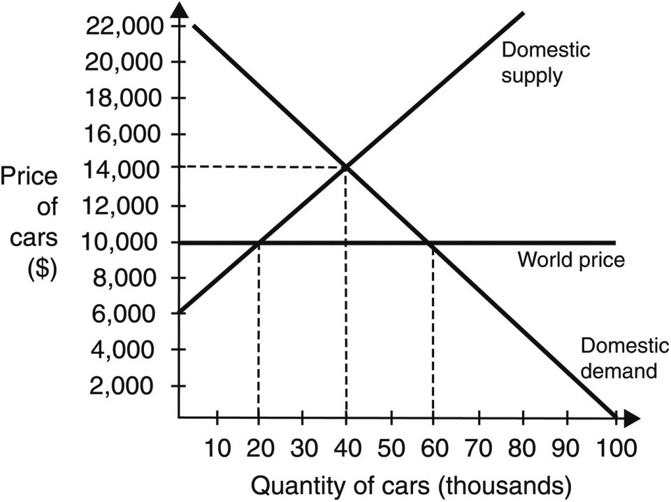

**1. Without trade with the rest of the world, the domestic equilibrium price of a car will be** ________.

* 1. $14,000
  2. $12,000
  3. $10,000
  4. $8,000
  5. $24,000

**2. Without trade with the rest of the world, the number of cars exchanged at equilibrium will be ________.**

* 1. 20,000
  2. 40,000
  3. 60,000
  4. 80,000
  5. 100,000

**3. If this economy trades with other countries, what will the price of a car be in this open economy?**

* 1. $6,000
  2. $8,000
  3. $10,000
  4. $14,000
  5. $24,000

**4. If this economy trades freely with other countries, without tariffs, the number of cars demanded will be ________.**

* 1. 20,000
  2. 40,000
  3. 60,000
  4. 80,000
  5. 100,000

**5. If this economy trades freely with other countries, without tariffs, the number of cars supplied by the domestic producers will be ________.**

* 1. 20,000
  2. 40,000
  3. 60,000
  4. 80,000
  5. 100,000

**6. How many cars will this country import in a trading (open) economy situation?**

* 1. 20,000
  2. 40,000
  3. 60,000
  4. 80,000
  5. 100,000

**7. Which of the following would be a characteristic of an open economy?**

* 1. An open economy trades all of its goods with the rest of the world.
  2. An open economy trades services but it does not trade its goods with the rest of the world.
  3. An open economy does not participate in international trade with other nations.
  4. An open economy trades both services and goods with other countries.
  5. An open economy trades only its goods but not services with the rest of the world.

**8. Which one of these statements is an accurate definition of trade balance?**

* 1. Trade balance is the sum of a nation’s total exports and total imports.
  2. Trade balance is the difference between a nation’s total exports and total imports.
  3. Trade balance is when a nation’s exports are greater than its imports.
  4. Trade balance is when a nation’s imports are greater than its exports.
  5. Trade balance is when a nation’s imports are equal to its exports.

**9. In recent years, the United States has:**

* 1. exported more services abroad than it has imported.
  2. imported more services from abroad than it has exported.
  3. had a small goods trade surplus with Japan.
  4. had a large goods trade surplus with the rest of the world.
  5. fallen to third behind Japan and Germany in the list of leading export nations.

**10. For a(n) ________, society’s production possibilities are the same as its consumption possibilities.**

* 1. closed economy
  2. open economy
  3. one-person economy
  4. free economy
  5. restricted economy

**11. An individual or country that has a comparative advantage in the production of one good:**

* 1. may be able to produce more of this good than any other individual or country.
  2. must use fewer resources in order to produce the same amount of the good than any other individual or country.
  3. must have a special talent or advantage that allows the individual or country to produce more of this good.
  4. must produce this good at a higher opportunity cost than any other individual or country.
  5. must produce this good at a lower opportunity cost than any other individual or country.

**12. In general, a nation can enjoy a higher standard of living by ________ than by being self-sufficient.**

* 1. increasing its versatility
  2. avoiding trade with other nations
  3. specializing and trading
  4. taxing imported goods
  5. producing on the PPF curve

***Use the following scenario to answer the next four questions.***

***Ruth and David use the same amount of resources to produce pizzas and calzones. Ruth produces four pizzas per hour or two calzones per hour. David produces three pizzas per hour or one calzone per hour.***

**13. Based on the scenario, David’s opportunity cost of producing a calzone is:**

* 1. three pizzas.
  2. one and a half pizzas.
  3. one-third of a pizza.
  4. one-third of a calzone.
  5. one calzone.

**14. Based on the scenario, Ruth’s opportunity cost of producing a calzone is:**

* 1. one-third of a calzone.
  2. one pizza.
  3. two pizzas.
  4. half of a pizza.
  5. three calzones.

**15. Based on the scenario, David’s opportunity cost of producing a pizza is:**

* 1. three calzones.
  2. one-third of a calzone.
  3. one-third of a pizza.
  4. half of a calzone.
  5. two calzones.

**16. Based on the scenario, Ruth’s opportunity cost of producing a pizza is:**

* 1. half of a calzone.
  2. half of a pizza.
  3. two calzones.
  4. two pizzas.
  5. three calzones.

***Use the following scenario to answer the next eight questions.***

***A worker in Vietnam can produce 2 computers and 16 pieces of clothing per day, while in Japan a worker can produce 5 computers and 10 pieces of clothing per day.***

**17. Assuming that both countries fully specialized in the good in which they have a comparative advantage and each country has 200 workers, what would be the total number of computers and pieces of clothing produced per day by both countries?**

* 1. 3,200 pieces of clothing and 1,000 computers
  2. 2,000 pieces of clothing and 400 computers
  3. 5,200 pieces of clothing and 1,400 computers
  4. 5,200 pieces of clothing and no computers
  5. 1,400 computers and no pieces of clothing

**18. The opportunity cost for Vietnam to produce a computer is ________ piece(s) of clothing.**

* 1. one-eighth of a
  2. one-quarter of a
  3. one
  4. eight
  5. four

**19. The opportunity cost for Japan to produce a computer is ____ piece(s) of clothing.**

* 1. one-quarter of a
  2. one-half of a
  3. one
  4. two
  5. three

**20. The opportunity cost for Vietnam to produce one piece of clothing is __ computer(s).**

* 1. one-quarter of a
  2. one-half of a
  3. one-eighth of a
  4. two
  5. four

**21. The opportunity cost for Japan to produce one piece of clothing is ____ computer(s).**

* 1. one-quarter of a
  2. one-half of a
  3. one
  4. two
  5. four

**22. ________ has the comparative advantage in computers, and ________ has the comparative advantage in pieces of clothing.**

* 1. Vietnam; Vietnam
  2. Vietnam; Japan
  3. Japan; Vietnam
  4. Japan; Japan
  5. None of these two countries has a comparative advantage in either good.

**23. Which of the following statements correctly describes the direction of trade between these two countries?**

* 1. Vietnam specializes in the production of clothing and exchanges some clothing for computers with Japan.
  2. Vietnam specializes in the production of computers and exchanges some computers for clothing with Japan.
  3. Vietnam and Japan do not engage in international trade because they have the same opportunity costs for both goods.
  4. There is not enough information to answer this question.
  5. Both countries produce both goods and consume what they produce.

**24. What is the maximum number of each item that can be produced in a day if each worker fully specializes and produces according to his comparative advantage?**

* 1. 13 pieces of clothing and 4 computers
  2. 10 pieces of clothing and 2 computers
  3. 16 pieces of clothing and 5 computers
  4. 26 pieces of clothing and 7 computers
  5. 10 pieces of clothing and 5 computers

**25. While comparative advantage is the biggest reason many nations engage in trade, two other important reasons are:**

* 1. economies of scale and increased competition.
  2. economies of scale and decreased competition.
  3. increased competition and increased production costs.
  4. increased production costs and access to smaller markets.
  5. decreased competition and access to smaller markets.

**26. When a smaller country with fewer resources specializes in the production of a good in which it has a comparative advantage and gains access to larger, international markets, this can create:**

* 1. a smaller distribution network.
  2. increased per-unit costs.
  3. decreased sales.
  4. economies of scale.
  5. inefficiencies.

**Use the graph to answer the next three questions.**

**The graph depicts the market for shoes in a particular country.**

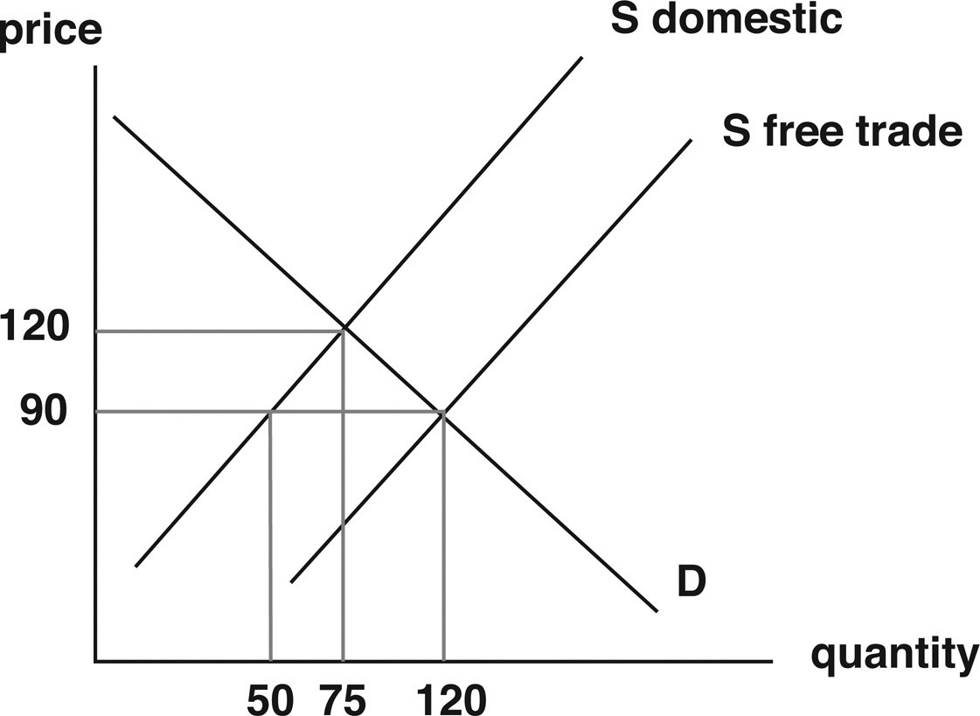

**27. If this country does not engage in trade with other countries, the price of shoes will be ________ and the number of shoes sold will be ________.**

* 1. $120; 120
  2. $120; 75
  3. $90; 120
  4. $90; 50
  5. $90; 75

**28. If this country engages in free trade with other countries, the price of shoes will be ________ and the number of shoes sold to domestic consumers will be ________.**

* 1. $120; 120
  2. $120; 75
  3. $90; 120
  4. $90; 50
  5. $90; 75

**29. If this country engages in trade with other countries, the number of shoes produced domestically will be ________ and the number of shoes imported will be ________.**

* 1. 50; 120
  2. 120; 50
  3. 50; 70
  4. 75; 45
  5. 75; 25

**30. When a country decides to begin importing a good they already produce domestically, then there will be an increase in ________ and the market price will ________.**

* 1. supply; increase
  2. supply; decrease
  3. demand; decrease
  4. demand; increase
  5. supply and demand; decrease

**31. Country A decides to sign a trade agreement with Country B. Suppose Country B specializes in producing electronics. We can expect the number of electronics imported from Country B to ________ and the price of electronics in Country A to ________.**

* 1. increase; increase
  2. increase; remain unchanged
  3. increase; decrease
  4. decrease; decrease
  5. decrease; increase

**Use the graph to answer the next three questions.**

**The graph shows the market for a particular good in Dorne. Dorne was importing the good under free trade and then decided to impose a tariff.**

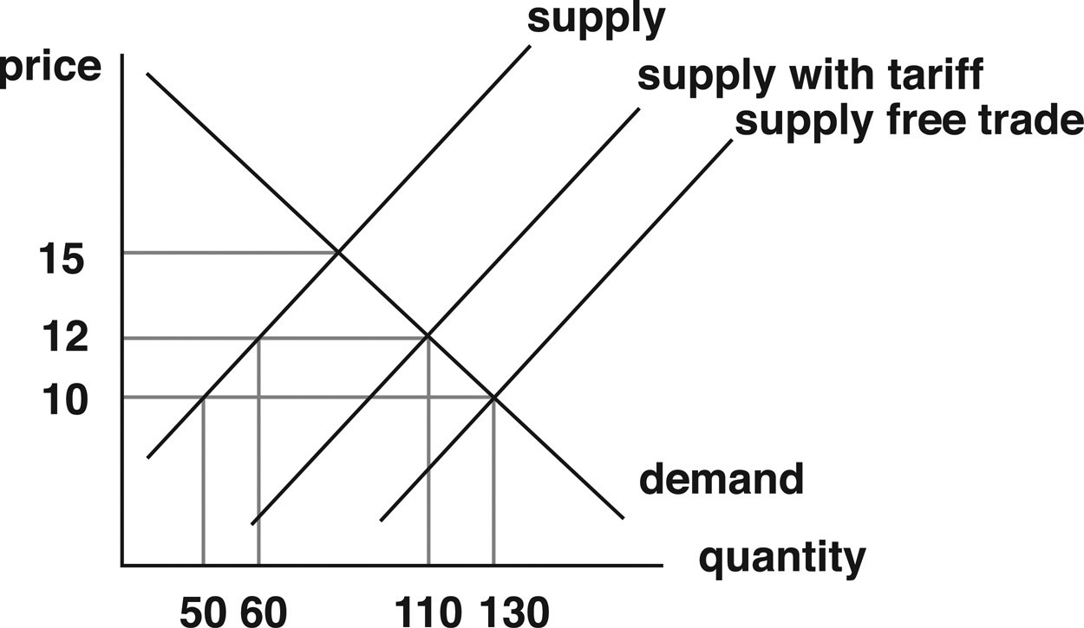

**32. What is the equilibrium price and quantity after the tariff is imposed in this market?**

* 1. $15 and 70 units
  2. $10 and 130 units
  3. $12 and 110 units
  4. $12 and 60 units
  5. Neither of them can be determined.

**33. How much revenue does the government earn from the tariff?**

* 1. $100
  2. $600
  3. $220
  4. $1,320
  5. $40

**34. When the tariff is imposed, imports will fall from ________.**

* 1. 130 to 110
  2. 80 to 50
  3. 60 to 50
  4. 20 to 10
  5. 130 to 60

**35. An example of a nonvoluntary import quota is:**

* 1. Japanese car manufacturers agreeing to limit exports to the United States.
  2. a decision by the United States to limit South Korean television imports to 100,000 per year.
  3. France charging an additional 10% tax on imports of Vietnamese clothing.
  4. a decision by Saudi Arabia to reduce oil exports to India by 100,000 barrels.
  5. Chinese toy manufacturers agreeing to reduce exports to the United States.

**36. In the domestic market, following the imposition of an import quota, imports ________, domestic production ________, and prices ________.**

* 1. decrease; increases; decrease
  2. increase; increases; increase
  3. decrease; increases; increase
  4. increase; decreases; decrease
  5. decrease; decreases; increase

**37. Which of the following is NOT one of the four main reasons for the persistence of trade barriers?**

* 1. National security.
  2. Protection of infant industries.
  3. Retaliation for dumping.
  4. Favors to special interests.
  5. Scarcity of natural resources.

**38. One argument for trade restriction that focuses on new industries is that:**

* 1. trade barriers must be used to protect all domestic workers.
  2. tariffs imposed to aid new industries should never be removed.
  3. new industries are usually capable of competing with established rivals.
  4. new industries need to be shielded in their early stages.
  5. trade barriers can be used to enhance national security.

**39. When a foreign supplier tries to “dump” goods into another country in order to gain a foothold in a foreign market, this is often a result of ________ within the foreign country.**

* 1. tariffs
  2. restrictions
  3. subsidies
  4. unemployment
  5. changed preferences

**40. Why do politicians sometimes resist free trade and “globalization”?**

* 1. Free trade does not benefit the economy as a whole.
  2. Special interest groups may not benefit from free trade.
  3. Free trade does not benefit the global economy.
  4. Free trade usually hurts consumers.
  5. Only the rich benefit from free trade.

**41. Which of the following statements about world trade is correct?**

* 1. Increased interdependence among nations has reduced world trade in the last 40 years.
  2. World trade rose dramatically in the last 40 years due to higher restrictions on trade.
  3. Increased specialization and reduced trade barriers are the reasons why world trade has grown in the last 40 years.
  4. World trade has grown in the last 40 years as market value, but not as a percentage of the world’s total output.
  5. World trade has grown in the last 40 years as a percentage of the world’s total output, but not as market value.

**42. If a country is running a trade deficit of $20 billion, which of the statements correctly describes the situation of this country?**

* 1. The country’s exports are $120 billion and its imports are $100 billion.
  2. The country’s exports and imports are equal to $20 billion.
  3. The country’s exports are $100 billion and its imports are $120 billion.
  4. The country’s exports plus its imports are $20 billion.
  5. None of these are correct.

**43. China imports soybeans from the United States, and the United States imports shoes from China. Assuming trade between China and the United States is based on comparative advantage, the opportunity cost of:**

* 1. shoes is lower in the United States than in China.
  2. soybeans is higher in the United States than in China.
  3. soybeans is higher in China than in the United States.
  4. both goods in both countries are the same.
  5. shoes is higher in China than in the United States.

**44. The cost of producing a bushel of wheat in Country A is $5, and the price at which Country A sells a bushel of wheat abroad is $4. This is an example of:**

* 1. import quota.
  2. import tariffs.
  3. dumping.
  4. economies of scale.
  5. export tariffs.

**45. Esther and Ebenezer produce hamburgers and hot dogs. Esther can produce six hamburgers per hour or four hot dogs per hour. Ebenezer can produce three hamburgers per hour or one hot dog per hour. Who has the absolute advantage and comparative advantage in the production of hamburgers and hot dogs?**

**46. Assume Country X and Country Y can produce two goods: Good A and Good B. Country X has abundant capital goods. Country Y, on the other hand, has abundant low-skilled labor but little capital. Production of Good A is capital intensive, while the production of Good B is labor intensive. Both countries have constant opportunity costs of production in both goods. The table shows the production possibilities for both countries.**

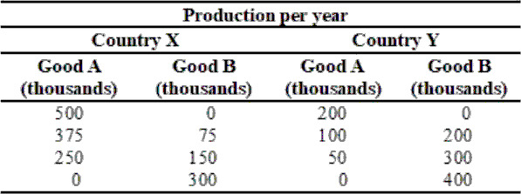

**A) Calculate the opportunity costs of Good A and Good B for Country X and Country Y.**

**B) Based on your answers to the previous question, answer the following questions: Which country has the comparative advantage in Good A? Which country has the comparative advantage in Good B?**

**C) If these two countries decide to trade with each other, which country will sell Good A? Which country will sell Good B? Explain why.**